**Assignment – 5**

**Tasks To Be Performed:**

1. Use the previous deployment

2. Deploy an NGINX deployment of 3 replicas

3. Create an NGINX service of type ClusterIP

4. Create an ingress service/ Apache to Apache service/ NGINX to NGINX

Service

1. Created an a.sh file and mentioned the required commands

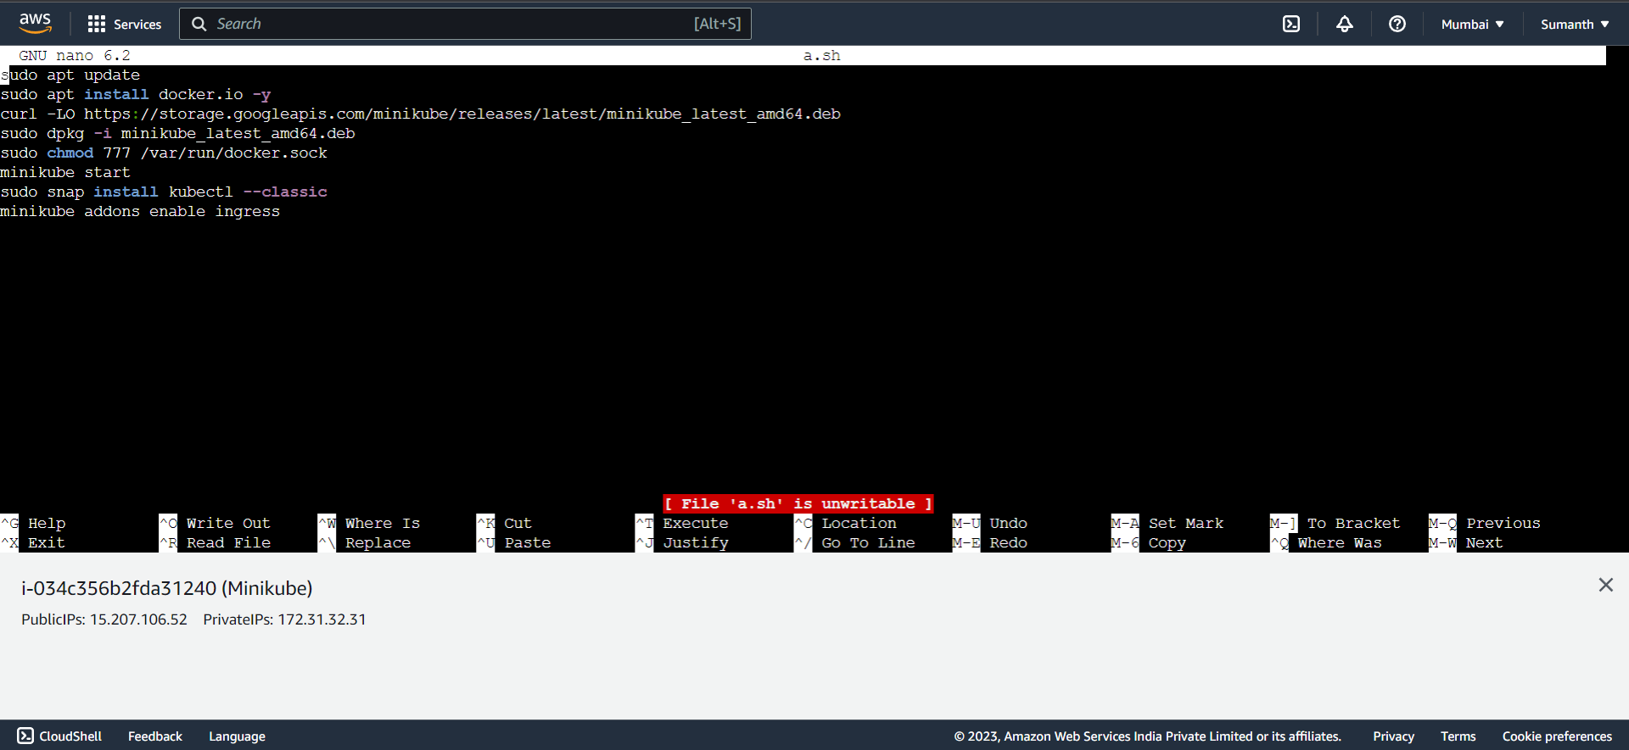

1. Created an ingress.yaml

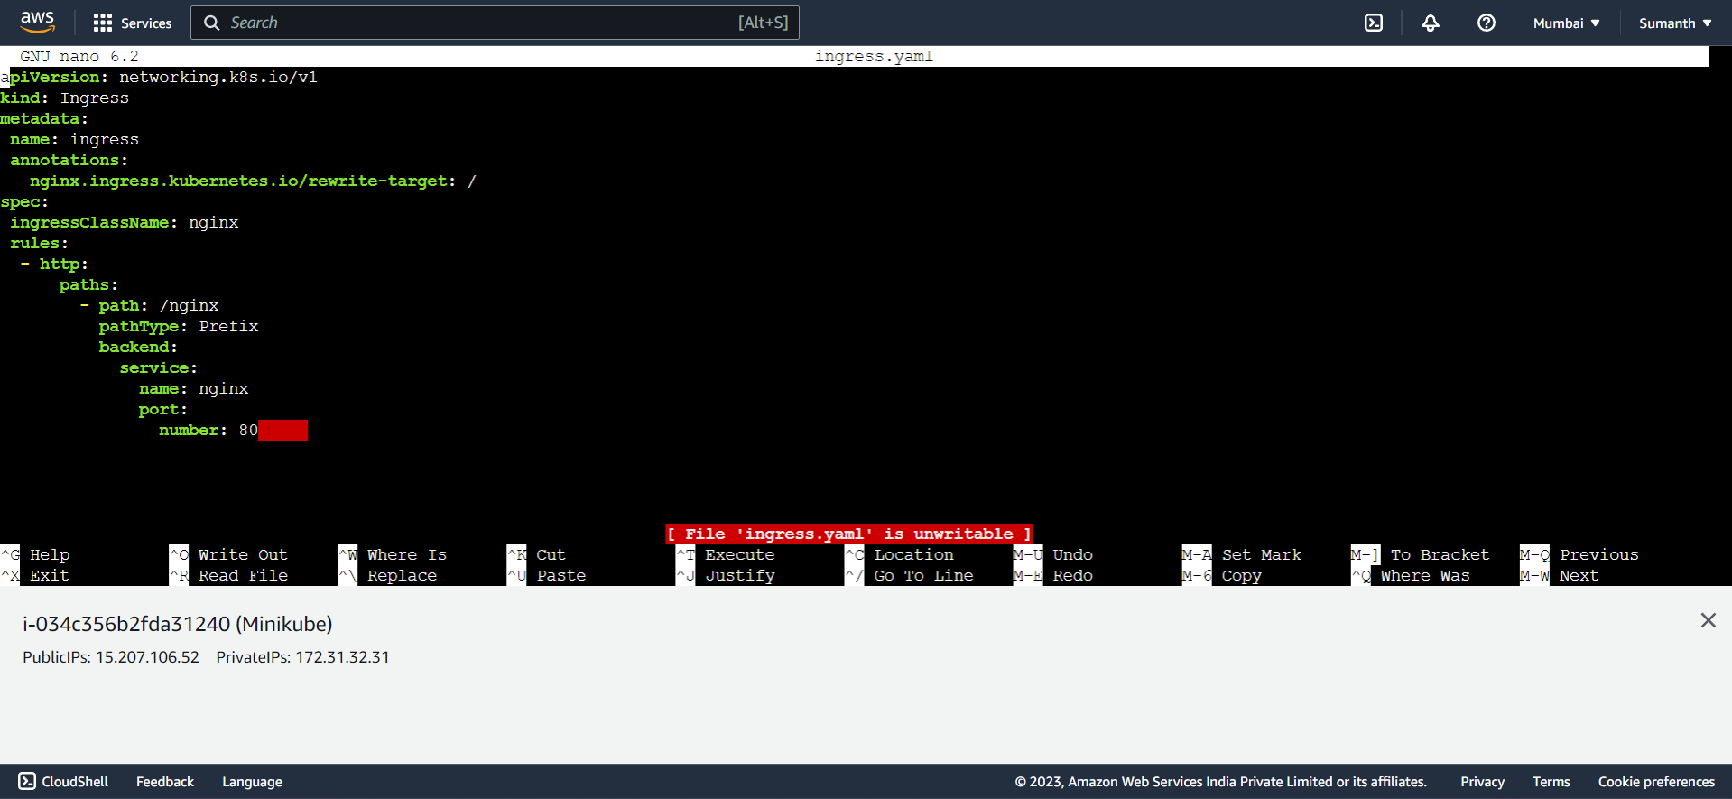

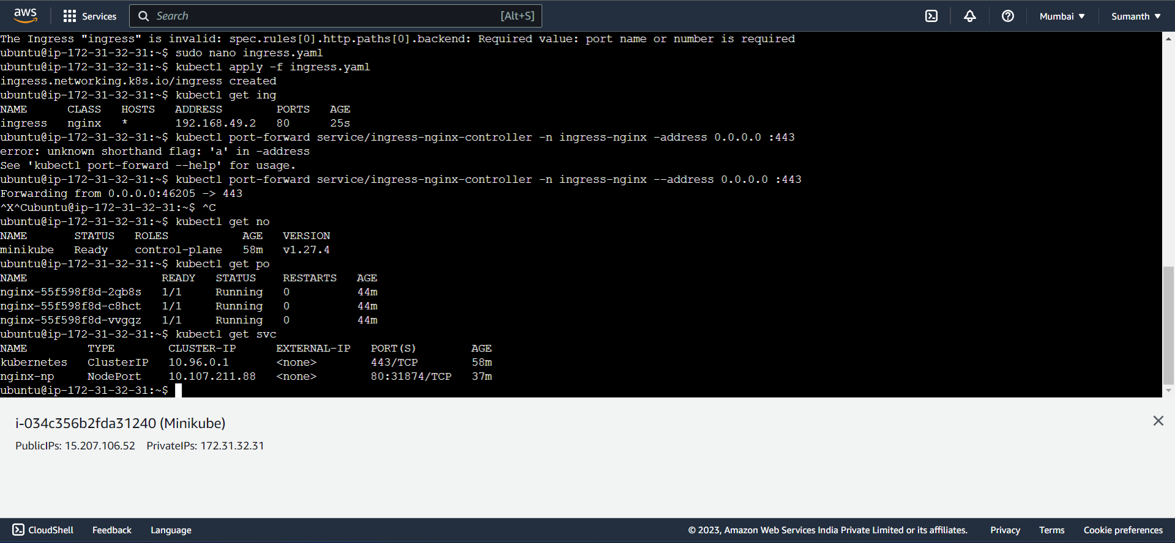

1. Commands used for the assignment

1 sudo apt update

3 sudo nano a.sh

6 bash a.sh

7 kubectl get no

8 kubectl create deployment nginx --image=nginx --port=80 --replicas=3

9 kubectl get deploy

19 kubectl expose deploy nginx --type=NodePort --name=nginx-np

20 kubectl get svc

21 kubectl port-forward service/nginx-np --address 0.0.0.0 :80

22 sudo apt update

25 sudo nano ingress.yaml

28 kubectl apply -f ingress.yaml

29 kubectl get ing

32 kubectl get no

33 kubectl get po

34 kubectl get svc